# Site Maps:

Home Page

The Twelve Apostles

Coffee tour in the CBD

Wilson’s Promontory Wildlife Park

Contact details.

# Wireframe

I have included my nav in my Footer and consulted my instructor, Hamoud, he has confirmed that this is valid and correct.

The aim of this design is to stand out and also to improve the navigation of the website.

Header

Main

Footer

nav

Nav

# Validation Results:

Page 1:

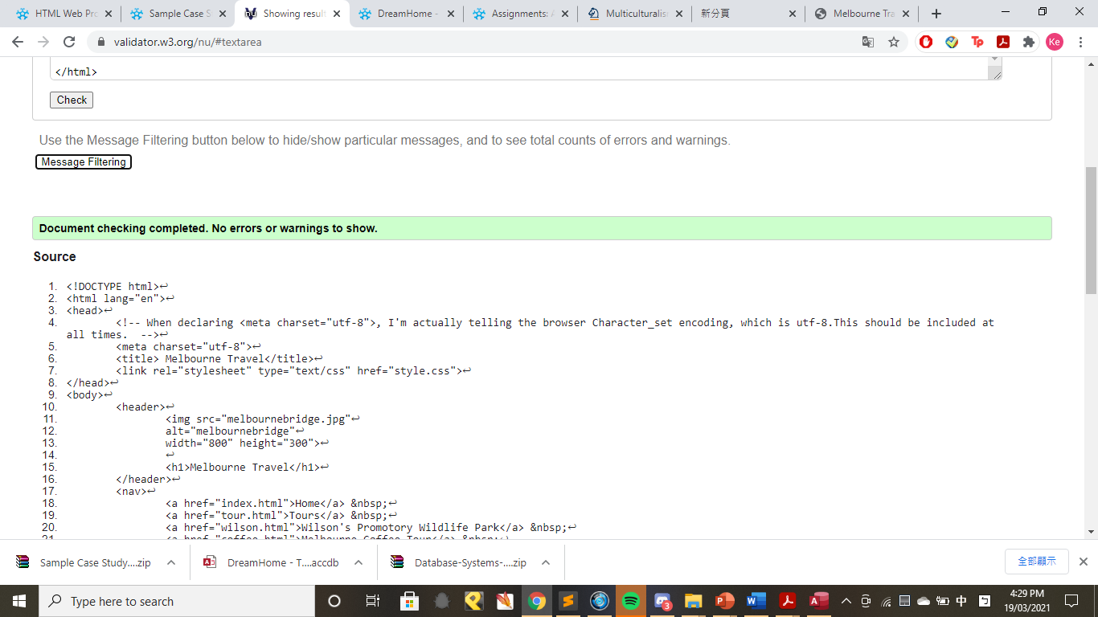

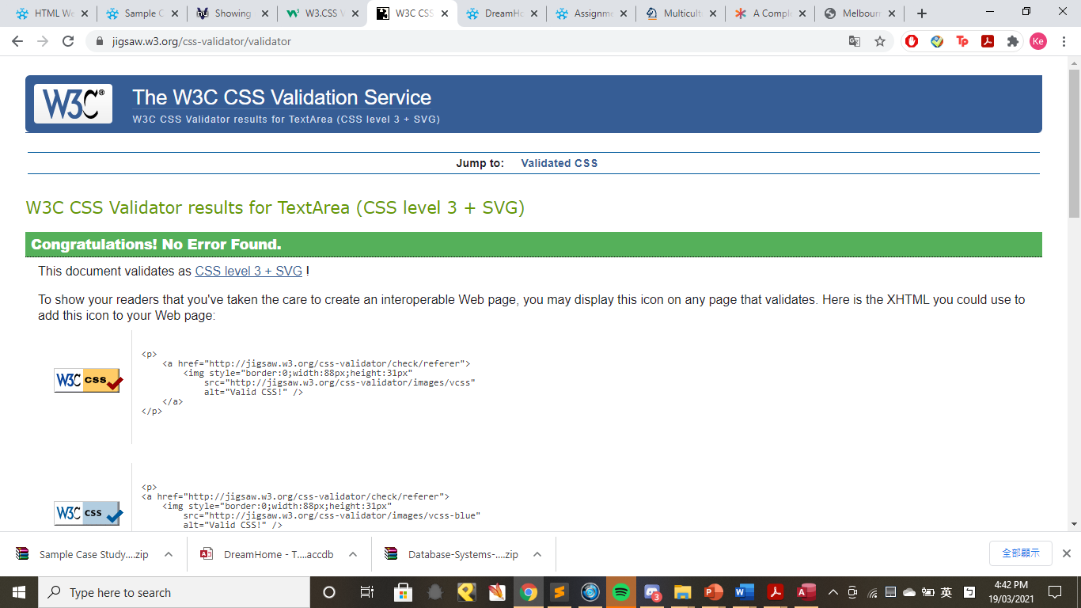

Page 2:

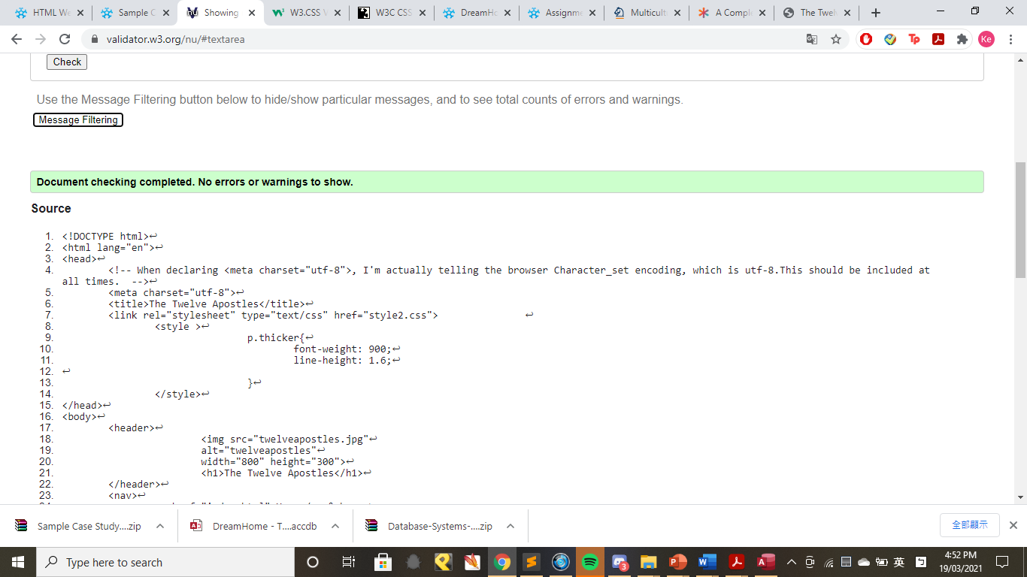

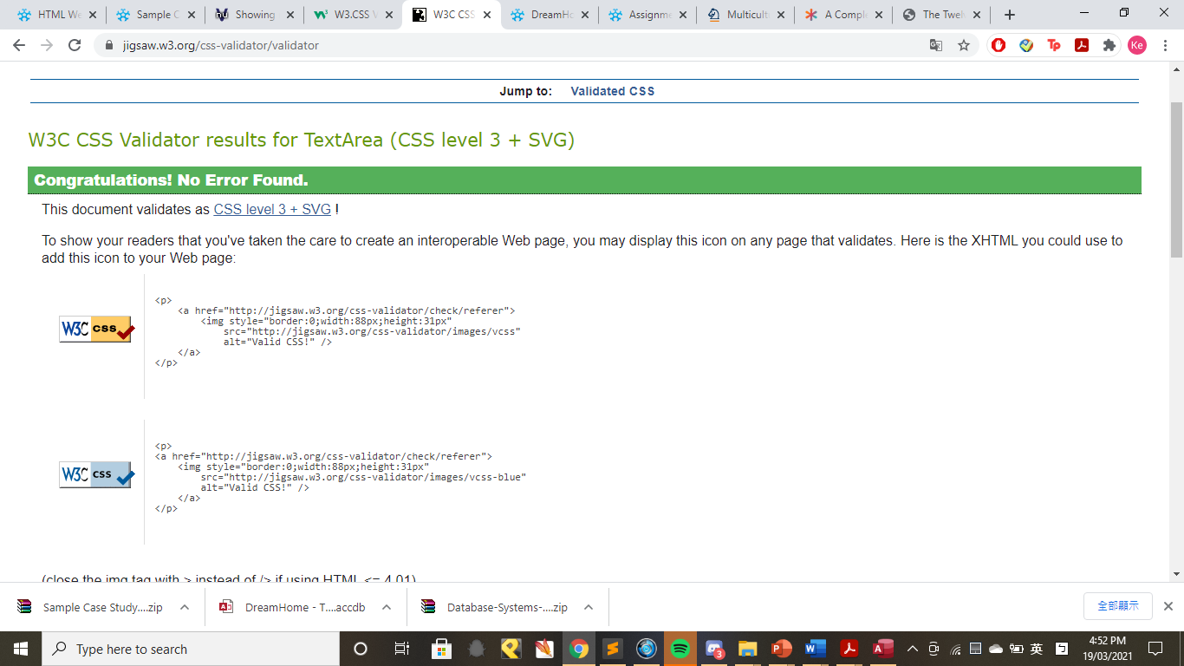

Page 3:

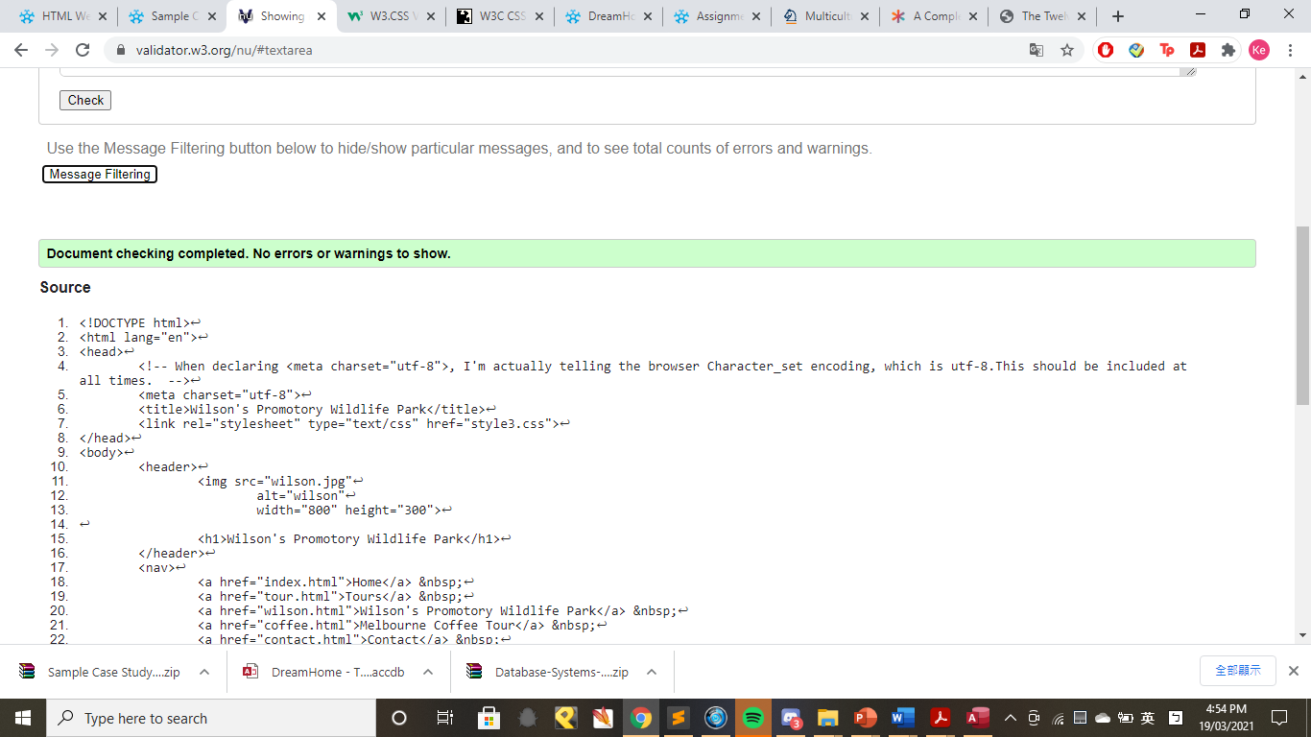

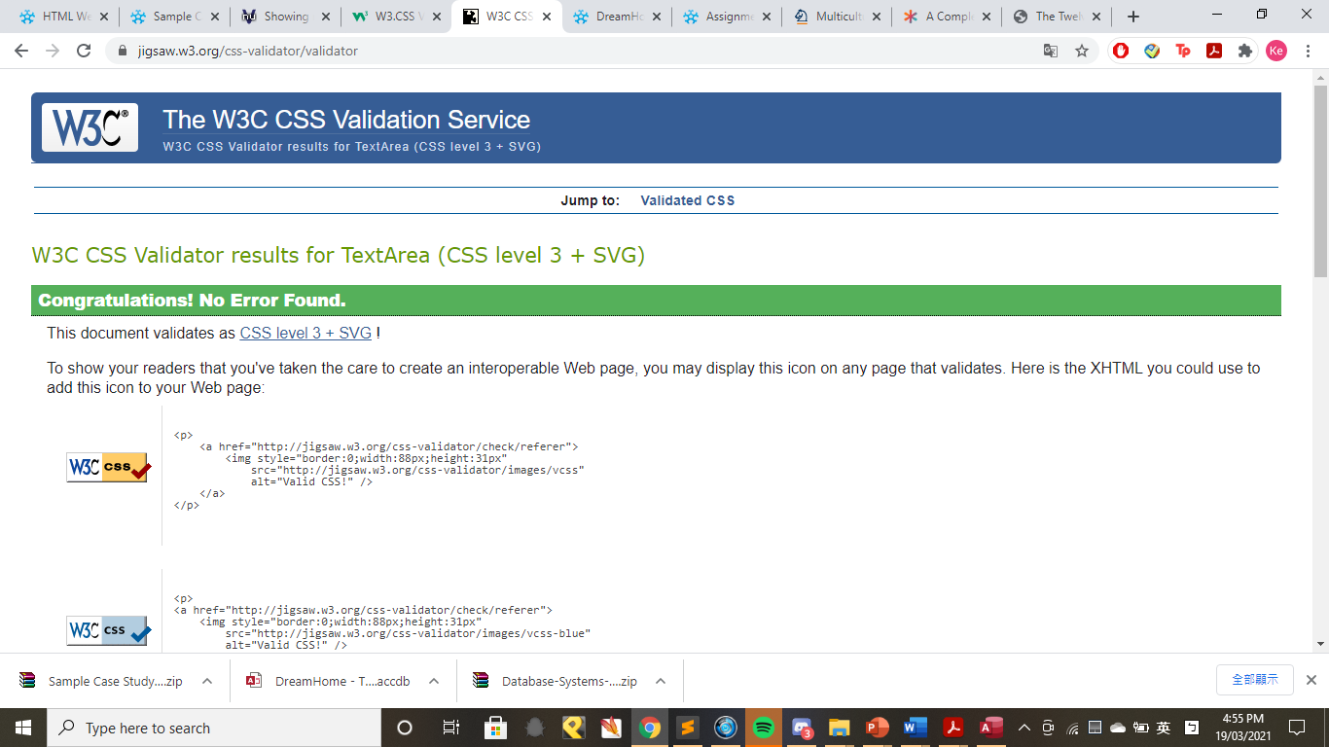

Page 4:

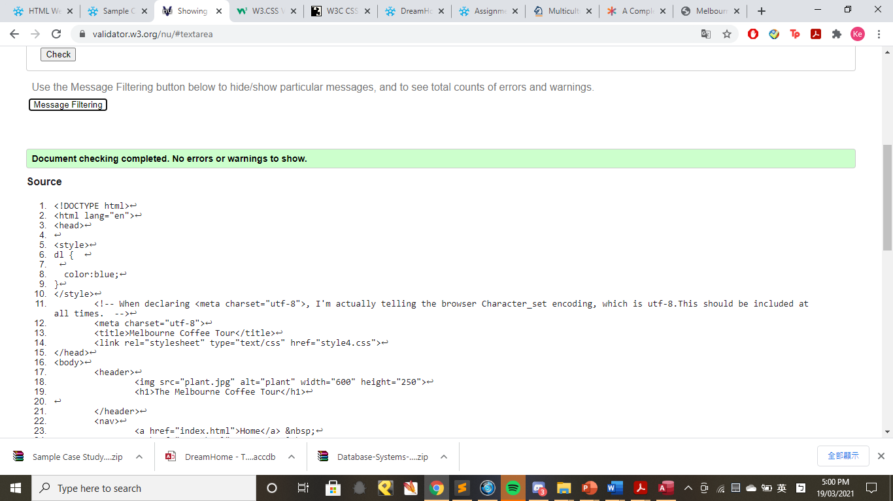

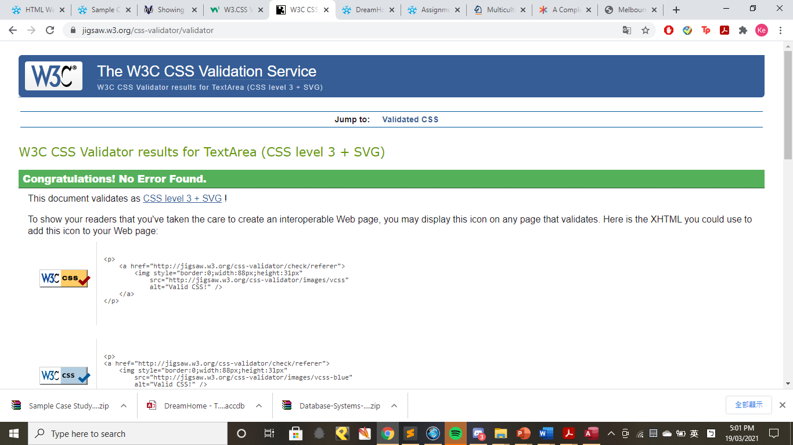

Page 5:

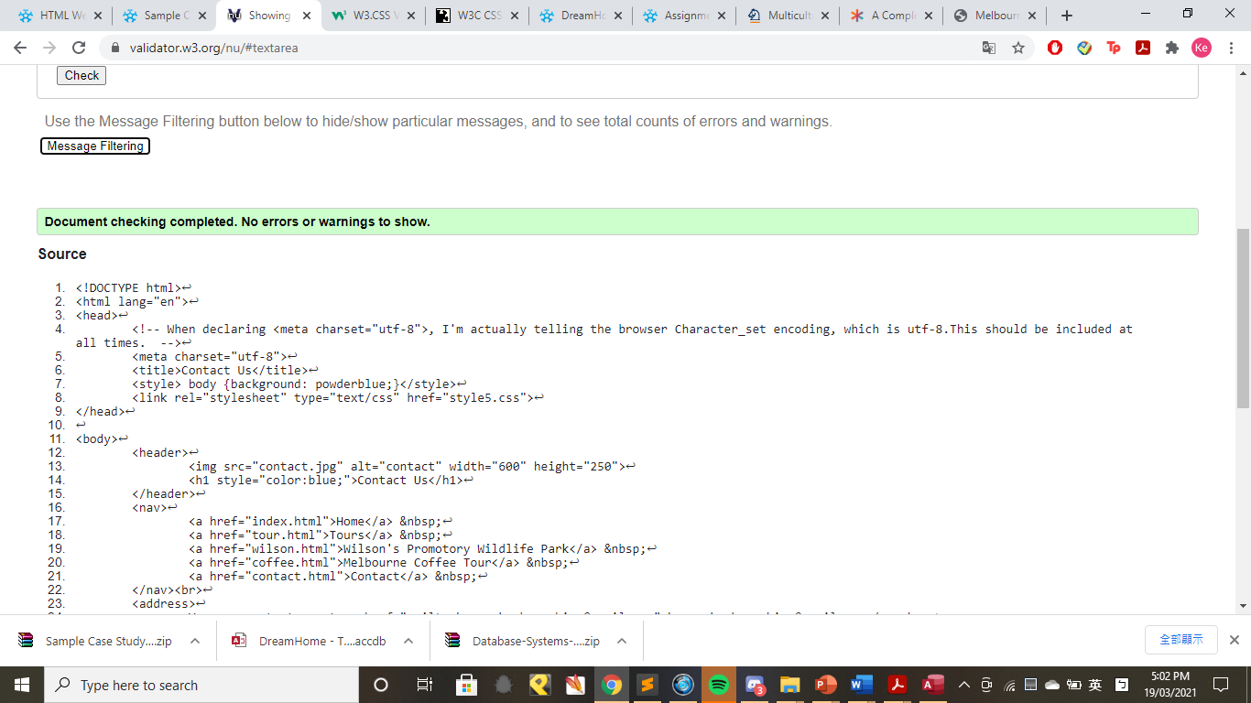

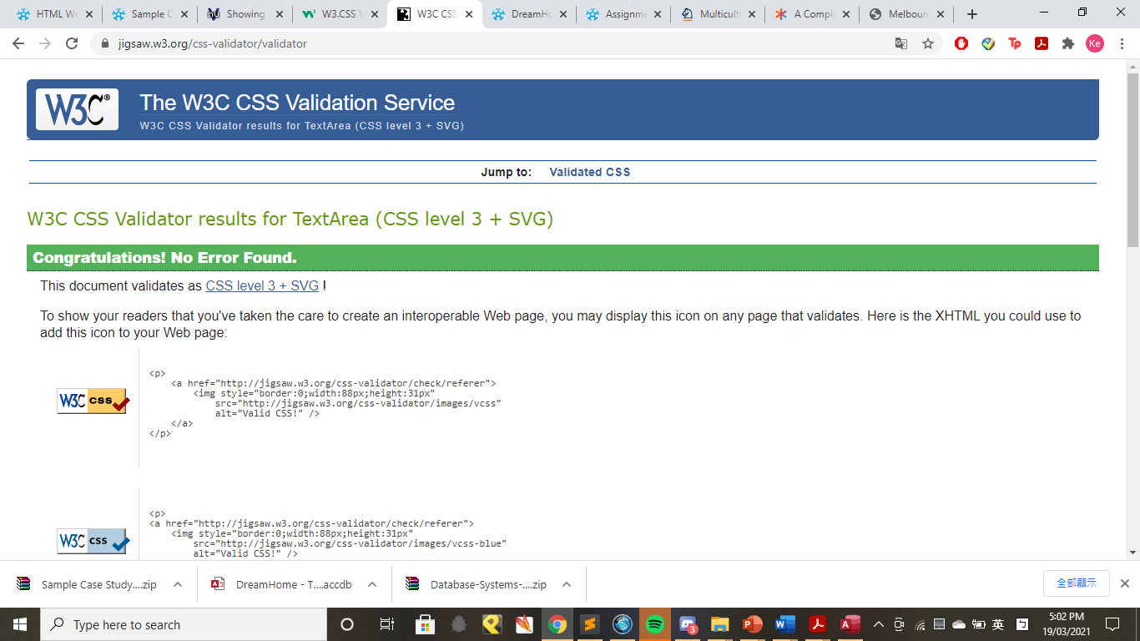

## References for my HTML and CSS Website

1. [Photograph]. (n.d.). Latte. Retrieved from <https://unsplash.com/photos/bbNssNJlsrk>
2. [Photograph]. (n.d.). Twelve Apostles, Melbourne, Australia. Retrieved from <https://unsplash.com/photos/1V6x6Td9vC8>
3. Barlin, T. B. (n.d.). Capppuccino with book [Photograph]. Retrieved from <https://unsplash.com/photos/GX4YM64o49U>
4. Calabrese, J. C. (n.d.). Melbourne, Victoria [Photograph]. Retrieved from <https://unsplash.com/photos/JI0KxozvOtQ>
5. Djojoseputro, R. E. D. (n.d.). Cappuccino [Photograph]. Retrieved from <https://unsplash.com/photos/YE5SgoHNByY>
6. Enad, L. L. E. (n.d.). Yarra River, Victoria [Photograph]. Retrieved from <https://unsplash.com/photos/EEHVl9zukc8>
7. Home, C. (n.d.). 12 Apostles, Australia [Photograph]. Retrieved from <https://unsplash.com/photos/7Qpp39GHY3w>
8. Jans, D. (n.d.). Melbourne, Australia [Photograph]. Retrieved from <https://unsplash.com/photos/-gmtAa0Q5MI>
9. Laszlo, S. L. (n.d.). Wilson’s Promontory [Photograph]. Retrieved from <https://unsplash.com/photos/M_zNsNPHXVE>
10. Maughan, E. M. (n.d.). Collingwood, Melbourne [Photograph]. Retrieved from <https://unsplash.com/photos/DmkpDy_au6M>
11. Sabeth, J. S. (n.d.). 12 Apostles [Photograph]. Retrieved from <https://unsplash.com/photos/mUIrV9j0zD0>
12. Yew, W. (n.d.). Flinders Street Railway Station [Photograph]. Retrieved from <https://unsplash.com/photos/iFdPrhOPI_E>
13. Chilver, T. C. (n.d.). Wilson’s Promontory [Photograph]. Retrieved from <https://unsplash.com/photos/ddXJic5I8H4>
14. Stone, N. (2018, July 1). What is Melbourne Coffee Culture and Why is it Special? Retrieved from <https://bluestonelane.com/what-is-melbourne-coffee-culture-goodfood/#:%7E:text=Good%20Food%20proposes%20that%20quite,than%20just%20premium%20Flat%20Whites>.
15. Wilsons Promontory National Park. (n.d.). Retrieved from <https://www.parks.vic.gov.au/places-to-see/parks/wilsons-promontory-national-park>
16. Hosseini, Z. H. (n.d.). Sand [Photograph]. Retrieved from <https://unsplash.com/photos/ObP1PNGUCdY>